Talk, Watch, Talk, Write: Japan; Land of the Rising Sun, Parts 4 – 7
Overriding Question: How did Japan change in the late 19th century?
Contextualization: During the 1500s, power was decentralized in Japan, which was torn apart by warfare between competing feudal lords (daimyo) for nearly a century. In 1600, however, Tokugawa Ieyasu swiftly consolidated power from his heavily fortified castle at Edo (now Tokyo). The prestigious but largely powerless imperial court named Ieyasu as shogun (or supreme military leader) in 1603, beginning a dynasty that would rule Japan for the next two-and-a-half centuries.
From the beginning, the Tokugawa regime focused on reestablishing order in social, political and international affairs after a century of warfare. The political structure established by Ieyasu and solidified under his two immediate successors bound all daimyos to the shogunate and limited any individual daimyo from acquiring too much land or power.
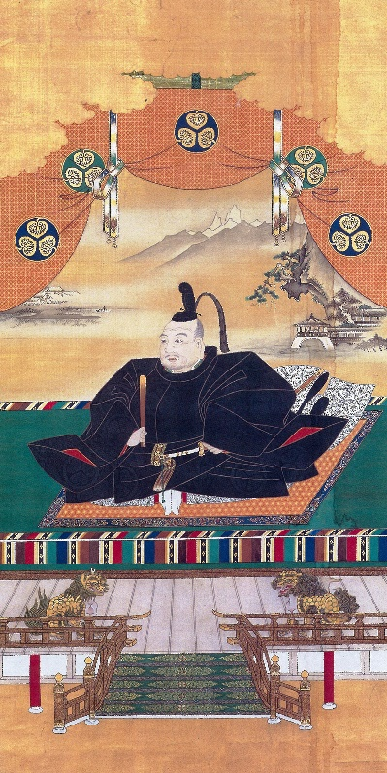
Suspicious of foreign intervention and colonialism, the Tokugawa regime acted to exclude missionaries and eventually issued a complete ban on Christianity in Japan. Near the beginning of the Tokugawa period, there were an estimated 300,000 Christians in Japan; after the shogunate’s brutal repression of a Christian rebellion Christianity was forced underground. The dominant faith of the Tokugawa period was Confucianism, a relatively conservative religion with a strong emphasis on loyalty and duty. Many Japanese continued to practice the Shinto religion -a devotion to invisible spiritual beings and powers called kami, to shrines, and to various rituals. In its efforts to close Japan off from damaging foreign influence, the Tokugawa shogunate also prohibited trade with Western nations and prevented Japanese merchants from trading abroad. With the Act of Seclusion (1636), Japan was effectively cut off from Western nations for the next 200 years (with the exception of a small Dutch outpost in Nagasaki Harbor). At the same time, it maintained close relations with neighboring Korea and China, confirming a traditional East Asian political order with China at the center.
The Neo-Confucian theory that dominated Japan during the Tokugawa Period recognized only four social classes–warriors (samurai), artisans, farmers and merchants–and mobility between the four classes was officially prohibited. With peace restored, many samurai became bureaucrats or took up a trade. At the same time, they were expected to maintain their warrior pride and military preparedness, which led to much frustration in their ranks. For their part, peasants (who made up 80 percent of the Japanese population) were forbidden from engaging in non-agricultural activities, thus ensuring consistent income for landowning authorities.
The Japanese economy grew significantly during the Tokugawa period. In addition to an emphasis on agricultural production (including the staple crop of rice as well as sesame oil, indigo, sugar cane, mulberry, tobacco and cotton), Japan’s commerce and manufacturing industries also expanded, leading to the rise of an increasingly wealthy merchant class and in turn to the growth of Japanese cities. A vibrant urban culture emerged centered in Kyoto, Osaka and Edo (Tokyo), catering to merchants, samurai and townspeople rather than to nobles and daimyo, the traditional patrons. The Genroku era (1688-1704) in particular saw the rise of Kabuki theater and Bunraku puppet theater, literature (especially Matsuo Basho, the master of haiku) and woodblock printing.
Watch Japan: Land of the Rising Sun
Section 5: Japan’s Period of Isolation
- What was the first foreign state to be invaded by Japan? When?
- How did the shoguns do to protect Japan from outside cultural; influence/
- How did Japan’s culture flourish under the Tokugawa – give example.
- How did the role of the samurai change in the Edo period?
- What role did Buddhism play during the Edo period?

Section 6: End of the Shogunate

- Who sailed into Edo Bay in 1853?
- What political change did the arrival of the Americans provoke?
Section 7: New Era in Japan
- What social change occurred with the Meiji Restoration?
- How did the Japanese military change in this era?
- How did the ancient traditions of Japan coexist in the new culture?
SAQ: 19th-Century Japan

- Explain ONE political change that occurred in Japan between 1850 and 1920.
______________________________________________________________________________________________________________________________________________________________________________________________________________________________________________________________________________________________________________________________________________________________________________________________________________________________________________________________________________________________________________________________

- Explain ONE social change that occurred in Japan between 1850 and 1920
______________________________________________________________________________________________________________________________________________________________________________________________________________________________________________________________________________________________________________________________________________________________________________________________________________________________________________________________________________________________________________________________

- Explain ONE cultural continuity that occurred in Japan between 1850 and 1920
______________________________________________________________________________________________________________________________________________________________________________________________________________________________________________________________________________________________________________________________________________________________________________________________________________________________________________________________________________________________________________________________

