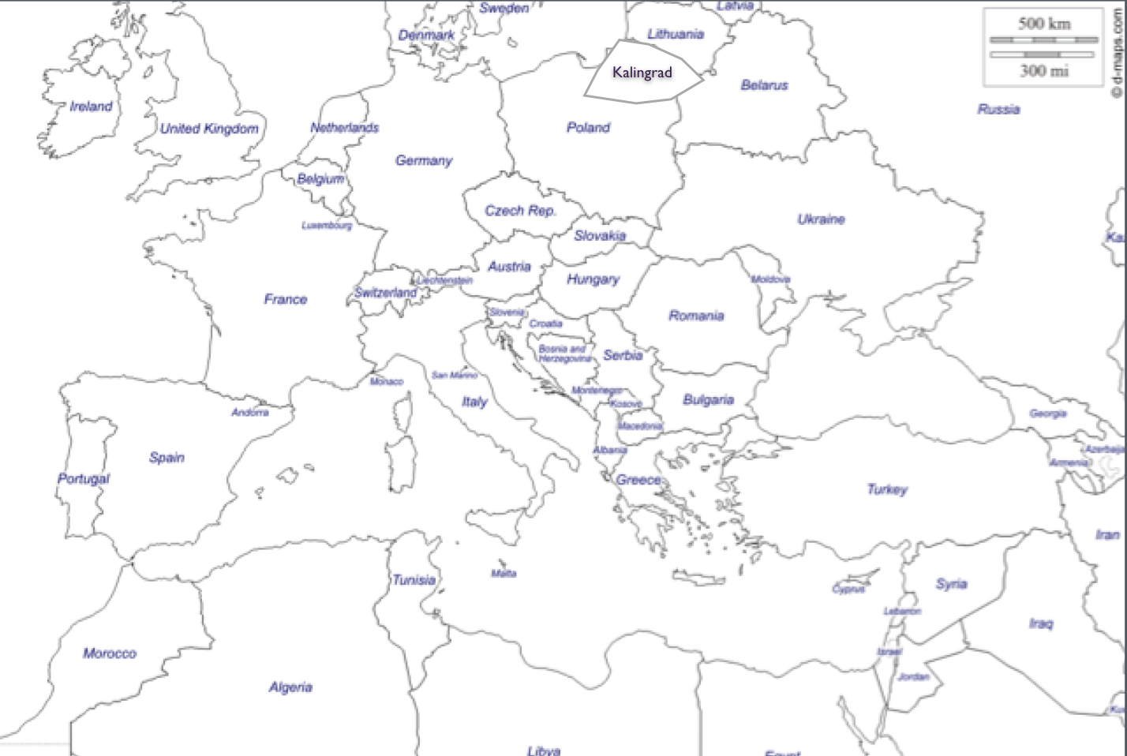

Name: _______________________________________________________________________________ Period: __________

POST WWI Map