DBQ Requirements

DBQ Student Learning Guide
The document-based question (DBQ) is designed to test your ability to work with and understand historical documents as well as to demonstrate a grasp of historical content and context. In the DBQ essay, you must
- Have a thesis that makes a historically defensible claim and responds to all parts of the question.
- Situate your argument by explaining the broader historical context, developments and processes.
- Use topic sentences that set out a relevant argument using a historical thinking skill.
- Demonstrate a complex understanding of the historical development that is the focus of the prompt by using evidence to corroborate, contradict, show cause and effect, show continuity and change over time, qualify (degree), or modify an argument by considering diverse views of evidence (depending on the prompt).
- Use the documents to support your arguments. (You should attempt to use all 7 documents; you may omit one, but that is a risk.)
- Explain the significance of the author’s point of view, the document’s historical situation, audience and/or the purpose of at least three documents.
- Refer to relevant specific historical evidence beyond that found in the documents. This evidence must be different from evidence used to earn other points on this rubric. A simple mention of evidence is NOT sufficient; you must explain the evidence in the course of your argument. Explaining how the evidence is similar to or different from given information is a good way to earn this point.

DBQ Pre-Write
Before starting on the historical DBQ, let’s review all of the steps in planning and writing the essay.

Time management
- Read and plan 15 minutes
- Write 45 minutes

Dissect the prompt
- What are the task and/or directive words?
- What are the parameters? (Time, place, class, categories, etc.)
- Are there any other key terms are in the prompt?

Planning
- As you read the documents, write brief summaries in the margins, look for patterns, content, contradiction and author type. Patterns are sometimes suggested in the prompt. Look for different points of view on the same topic.
- Plan your categories to match the supporting documents. Remember to be constantly aware of the prompt.
- A document may fit in more than one category or it may stand alone.
- In general, this will be a 5-paragraph essay: Contextualization, Thesis, Argument 1, Argument 2, and Argument 3.

Writing the DBQ

DBQ Student Learning Guide

The following prompt and documents will be used as the basis for the examples of each part of the DBQ explained below:

Prompt: Evaluate the extent to which urban centers served as hubs of economic activity between the twelfth and seventeenth centuries.

Document 1
Anonymous, excerpt from a Byzantine text, The Timarion, “The Great Fair at Thessalonica,” c. 1150.

The Demetria is a festival, …the most important fair held in Macedonia. Not only do the natives of the country flock together to it in great numbers, but multitudes also come from all lands and of every race - Greeks, … the Bulgarians, Neapolitans, Spaniards, Portuguese, and French; and, to make a long story short, the shores of the ocean send pilgrims and suppliants to visit the martyr, so widely extended is his fame throughout Europe. … What I saw there was a number of merchants' booths, set up in parallel rows opposite one another; … here was every kind of material woven or spun by men or women, all those that come from Boeotia and the Peloponnese, and all that are brought in trading ships from Italy to Greece.

Document 2
Yakut al-Hamawī, a Greek merchant and scholar who lived in the Abbasid Empire, from his book, Baghdad Under the Abbasids, c. 1228.

Baghdad was a veritable City of Palaces, not made of stucco and mortar, but of marble. The buildings were usually of several stories. The palaces and mansions were lavishly gilded and decorated….Both sides of the river were for miles fronted by the palaces, kiosks, gardens and parks of the grandees and nobles, marble steps led down to the water’s edge, and the scene on the river was animated by thousands of gondolas, decked with little flags, dancing like sunbeams on the water, and carrying the pleasure-seeking Baghdad citizens from one part of the city to the other. Along the wide-stretching quays lay whole fleets at anchor, sea and river craft of all kinds, from the Chinese junk to the old Assyrian raft resting on inflated skins. The mosques of the city were at once vast in size and remarkably beautiful. There were also in Baghdad numerous colleges of learning, hospitals, infirmaries for both sexes, and lunatic asylums.

Document 3

DBQ Student Learning Guide
Marco Polo, Venetian traveler, excerpt from The Book of Ser Marco Polo: The Venetian: Concerning Kingdoms and Marvels of the East, c. 1300.

Suzhou (a city in China) is a very great and noble city. The people are Idolaters, subjects of the Great Khan, and have paper money. They possess silk in great quantities, from which they make gold brocade and other stuffs, and they live by their manufactures and trade… and since they were conquered by the Great Khan they use paper-money.
The city is passing great and has a circuit of some 60 miles; it hath merchants of great wealth and an incalculable number of people. … There are also in this city many great philosophers and leeches, diligent students of nature.

Document 4
Ibn Battuta, Moroccan traveler, and quadi, excerpt from his book, Rilha: Travels in Asia and Africa, c. 1354.
We then reached Jerusalem, third in excellence after the two holy shrines of Mecca and Medina and the place whence the Prophet was caught up into heaven. Its walls were destroyed by the illustrious King Saladin and his Successors, for fear lest the Christians should seize it and fortify themselves in it. The sacred mosque is a most beautiful building and is said to be the largest mosque in the world… The greater part is covered with gold so that the eyes of one who gazes on its beauties are dazzled by its brilliance, now glowing like a mass of light, now flashing like lightning. In the center of the Dome is the blessed rock from which the Prophet ascended to heaven…
I travelled next to the country of Hormuz. Hormuz is a town on the coast… It is a large and fine city, with busy markets, as it is the port from which the wares from India and Sind are dispatched to the Iraqs, Firs and Khurasan. …Water is a valuable commodity in this island. They have wells and artificial reservoirs to collect rainwater at some distance from the town. The inhabitants go there with waterskins, which they fill and carry on their backs to the shore, load them on boats and bring them to the town.

Document 5
Bernal Diaz del Castillo, Spanish conquistador, excerpt from his book: History of the Conquest of New Spain describing Tenochtitlan, written in 1576.
So we stood looking about us, for that huge and cursed temple stood so high that from it one could see over everything very well, and we saw the three causeways which led into Mexico, … we beheld on that great lake a great multitude of canoes, some coming with supplies of food and others returning loaded with cargoes of merchandise…and we saw that from every house of that great city and of all the other cities that were built in the water it was impossible to pass from house to house, except by drawbridges which were made of wood or in canoes; and we saw in those cities Cues [temples] and oratories like towers and fortresses and all gleaming white, and it was a wonderful thing to behold; ….After having examined and considered all that we had seen we turned to look at the great market place and the crowds of people that were in it, some buying and others selling… Some of the soldiers among us who had been in many parts of the world, in Constantinople, and all over Italy, and in Rome, said that so large a market place and so full of people, and so well regulated and arranged, they had never beheld before.

Document 6

DBQ Student Learning Guide
Leo Africanus, a Muslim scolar from Morocco living in Italy, excerpt from The Description of Africa, written for the Pope Leo X, 1526.
The houses of Timbuktu are huts made of clay-covered wattles with thatched roofs. In the center of the city is a temple built of stone and mortar and in addition there is a large palace, constructed by the same architect, where the king lives. The shops of the artisans, the merchants, and especially weavers of cotton cloth are very numerous. Fabrics are also imported from Europe to Timbuktu, borne by Berber merchants.
…salt is in very short supply because it is carried here from Taghaza, some 500 miles from Timbuktu. I happened to be in this city at a time when a load of salt sold for eighty ducats. The king has a rich treasure of coins and gold ingots.
Only small, poor horses are born in this country. The merchants use them for their voyages and the courtiers to move about the city. But the good horses come from Barbary. They arrive in a caravan and, ten or twelve days later, they are led to the ruler, who takes as many as he likes and pays appropriately for them.
The king … greatly honors learning. Many hand-written books imported from Barbary are also sold. There is more profit made from this commerce than from all other merchandise.

Document 7
Anonymous Portuguese cartographer, The Cantino Map, famous for its early, correct use of latitude, 1502.
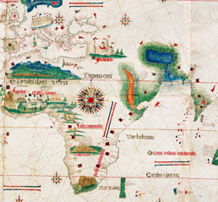

Thesis: Write a thesis paragraph that addresses the prompt and has historically defensible arguments (at least one, but ideally 3) for analysis. Look for a key word in the prompt like: relationship, aspects, characteristics, views, hubs, etc. A good thesis will incorporate all the key terms from the prompt. The purpose of the thesis is to lay out the order of the essay’s argument. For clarity, explain each category of your argument in a separate sentence. This is not the place to refer to specific document numbers, save that for evidence in the body paragraphs.

DBQ Student Learning Guide

A good thesis will follow the pattern below:

Thesis Example: Between the 12th and 17th centuries, cities served as important hubs of economic activity as centers of long-distance and regional trade. They served as important trading centers because they were home to a lot of people, and the wealth there attracted merchants. They were also home to cultural attractions such as universities, fairs, and holy places, that drew even more people and increased trade in the process. [Notice that the categories have some elaboration to them as well as the historical thinking skill, in this case causation. The argument is nuanced in that it not only points out how cities were economically significant, but also why, therefore guiding the essay toward being more complex.]

Contextualization: Situate the argument by explaining the broader historical events, developments, or processes immediately relevant to the question.

College Board states, “Historical thinking involves the ability to connect historical events and processes to specific circumstances of time and place and to broader regional, national, or global processes.” In other words, put the question in the context of the bigger picture. The best place to do this is at the beginning of your essay, either before or after your thesis paragraph.

Contextualization Example A: Between the 12th and 17th century, Dar al-Islam, the Mongol Empire, and China’s Song and Ming dynasties helped unify and protect large portions of the Eurasian trade routes. At the same time, new technology for land and sea travel made long trips easier. Because of this, trade, especially in luxury goods, increased, and cities began to spring up along the trade routes. [This works well as it provides a background in which the DBQ prompt is set.]

Contextualization Example B: Cities were affected by many problems between the 12th and 17th centuries. Sometimes the problem was man-made – like the arrival of Mongol armies. At other times the problems were biological, like when the Black Death decimated the cities of Europe in the 14th century. [While the information provided is not wrong, this paragraph would not earn the point for contextualization as it is irrelevant to the topic of the prompt (economic activity in urban centers).]

Argument Development and Complexity: Write each body paragraph to cover ONE argument put forward in the thesis. Start each paragraph with a topic sentence. Use the documents as evidence to support the argument made in your topic sentence. All documents must be addressed individually, not discussed in groups. For example, do NOT write sentences like: “Documents 1 and 2 both discuss how cities were used as religious centers” Do not list the documents by number in your topic sentence.

Complexity is demonstrated with a response that weaves the documents, sourcing and outside evidence into the arguments, showing a clear understanding of the subject and a nuanced view. Although, in theory, all of the points in the essay can be earned independently, it is very difficult to earn the complexity point without having earned most or all of the other points.

DBQ Student Learning Guide

The complexity point can be earned a number of ways. Generally speaking, it is earned through using the documents to corroborate, qualify, or modify the argument. This thesis sets up the essay for a complexity point by responding to the prompt with the argument that cities were significant economic hubs as centers of long-distance trade. It becomes complex when it goes on to modify the argument by explaining why cities became that way in the first place—because of a high concentration of people and wealth, as well as the further draw of cultural attractions. Complexity must be present throughout the entire essay—not simply injected in a single body paragraph. Essays that earn complexity typically link one paragraph to the next, showing how each topic of the essay responds to the prompt and also relates to each other. Complex arguments generally require ample amounts of document sourcing and at least one piece of evidence beyond the documents to adequately prove their point.

(Other, more difficult ways to earn complexity when responding to the sample prompt would be to continually draw comparisons between the economic significance of cities in the 12th-17th centuries and the economic significance of cities in the 19th-20th centuries. Or, it could be earned by making a comparison of the economic significance of cities in different regions, for example—compare cities in Europe as to cities in East Asia. Another way would be to address the “extent” of the economic significance of cities in response to the prompt by arguing that cities weren’t all that important for economic activity and use nuanced interpretations of the documents to prove it—it would be extremely difficult to do, but if done, it would earn the point.)

A good body paragraph will follow the pattern below:

Body Paragraph Example: Urban centers served as significant hubs of economic activity by being centers of long-distance and regional trade. Ibn Battuta records the trading activity of the city of Hormuz in Document 4, as he recalls how goods arrived from across the Indian Ocean – probably fine cottons or precious stones. Long-distance travel was expensive and risky at this time, so it shows the economic importance of Hormuz that a merchant was willing to take that risk to travel there for trade. Long-distance trade in cities is also shown in Document 6, when Leo Africanus talks about the importance of Timbuktu as a trading hub by pointing out that Berbers carry fine fabrics from Europe all the way to this city in the desert region of Africa. Leo Africanus was sent by a rich and powerful pope to explore this region and so produces an account that highlights the trading opportunities that make crossing the Sahara Desert worth it. The idea that cities served as important trading centers, and thus were worth reporting about, is corroborated in Document 5, when Diaz testifies that Tenochtitlan has a superior market place to any of the great cities in Europe. Diaz had noticed the fine goods the Aztec were given as tribute from their subjects throughout their empire, and he writes about it in the hope that other Spanish conquistadors will take up the challenge of trans-Atlantic adventures. [This is a good body paragraph because reasoning is used by directing all documents back to one appropriate argument set out in a topic sentence. Sourcing is provided for both Documents 5 and 6, and complexity is building through the use of corroborating documents.]

Evidence beyond the documents: A point is awarded in the DBQ essay for appropriate use of evidence beyond the documents. The outside evidence must be explained in the course of an argument that is related to the prompt. It cannot be simply a fact dropped into a discussion, it must be additional specific evidence that supports the argument being made in response to the prompt. Therefore, it must be located in one of the body paragraphs, NOT the contextualization paragraph.

DBQ Student Learning Guide
Below are two examples of attempted evidence beyond the documents to go along with the body paragraph example on the previous page; the first illustrates the common mistake of simply providing related facts as evidence, the second properly provides evidence that supports an argument.

Example A (facts dropped into the discussion): Ibn Battuta wasn’t the only famous Muslim to go on hajj. Mansa Musa, king of Mali, also took a famous trip to the holy city of Mecca. Mansa Musa was the richest man in the world at that time, and had converted to Islam after he accidentally killed his own mother. [This does NOT count as evidence beyond the document because it does not add to the argument.]

Example B (facts supporting an argument): Not only were Timbuktu and Hormuz vibrant economic hubs, but so was Constantinople, which served as a trading hub between Africa, Asia and Europe. Even after the city was taken by the Ottomans and renamed Istanbul, it continued to boom as an important center of commerce. [This DOES count as evidence beyond the document because it adds another example to support the argument that cities flourished as trading centers.]

Below is the pre-write chart for the DBQ used in the examples above. Notice how the chart works as an outline for the essay.
Prompt: Evaluate the extent to which urban centers served as hubs of economic activity between the twelfth and seventeenth centuries.

DBQ Pre-Write

Argument Categories  (urban=economic) | Document #s | Document Sourcing (POV)
centers of long-distance and regional trade  large amounts of people and wealth draw merchants  cultural attractions draw more people, promote economic activity | 1  3  4  5  6  7  1  7  1  2  4 | Doc 3 – S= merchant (Marco Polo)  O= seeing China’s vast economy in action  A= European elite, merchants  P= excite others about trade possibilities  Evidence beyond document: Constantinople-important trading  hub  Doc 7 – S= Spanish mapmaker  O= beginning of the age of exploration  A= rulers and ship captains  P= make exploration easier, latitude  Doc 4 – S= qadi, Islamic judge (Ibn Battuta)  O= visiting Jerusalem, a holy city  A= Muslim elites  P= glorifying the beauty and prosperity of an Islamic  holy place
Context: new transportation technologies make travel easier, large portions of trade routes are united by a common government and/or culture, increased trade of luxury goods, cities sprung up along trade routes.…
What would your context and thesis paragraphs look like?

DBQ Student Learning Guide
_________________________________________________________________________________________________________________________________________________________________________________________________________________________________________________________________________________________________________________________________________________________________________________________________________________________________________________________________________________________________________________________________________________________________________________________________________________________________________________________________________________________________________________________________________________________________________________________________________________________________________________________
_________________________________________________________________________________________________________________________________________________________________________________________________________________________________________________________________________________________________________________________________________________________________________________________________

What would your three topic sentences be for your categorical body paragraphs?
- ______________________________________________________
______________________________________________________________________________________________________________
- ______________________________________________________
______________________________________________________________________________________________________________
- ______________________________________________________
______________________________________________________________________________________________________________

DBQ Practice I: Cross-Cultural Contact

DBQ Student Learning Guide
The document-based question (DBQ) is designed to test your ability to work with and understand historical documents as well as to demonstrate a grasp of historical content and context. In the DBQ essay, you must
- Have a thesis that makes a historically defensible claim and responds to all parts of the question.
- Situate your argument by explaining the broader historical context, developments and processes.
- Use topic sentences that set out a relevant argument using a historical thinking skill.
- Demonstrate a complex understanding of the historical development that is the focus of the prompt by using evidence to corroborate, contradict, show cause and effect, show continuity and change over time, qualify (degree), or modify an argument by considering diverse views of evidence (depending on the prompt).
- Use the documents to support your arguments. (You should attempt to use all 7 documents; you may omit one, but that is a risk.)
- Explain the significance of the author’s point of view, the document’s historical situation, audience and/or the purpose of at least three documents.
- Refer to relevant specific historical evidence beyond that found in the documents. This evidence must be different from evidence used to earn other points on this rubric. A simple mention of evidence is NOT sufficient; you must explain the evidence in the course of your argument. Explaining how the evidence is similar to or different from given information is a good way to earn this point.

Prompt: Evaluate the extent to which culture in the Indian Ocean area was affected by inter-regional interactions during the fourteenth through sixteenth centuries.

Note: The map below shows the locations mentioned in the documents and is provided as a reference. The map is NOT one of the seven documents. The documents begin on the next page.

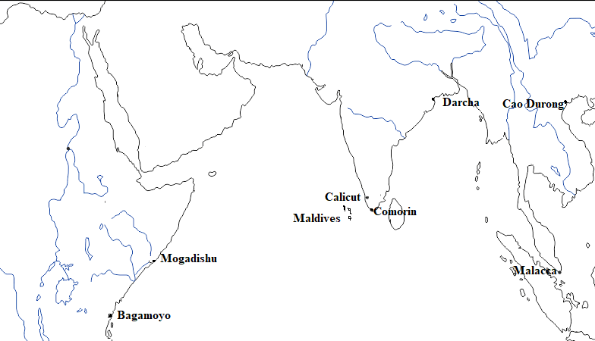

Document 1

DBQ Student Learning Guide
Bagamoyo Mosque (ruins) in East Africa built by Bantu peoples c. 1350.
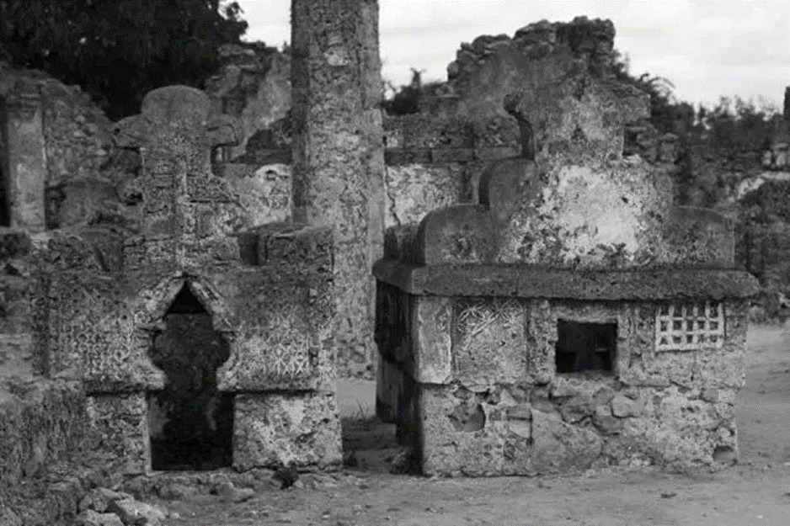

Document 2
Ibn Battuta, Moroccan traveler, excerpt from his book, Rihla: Travels in Asia and Africa, c. 1354.

We stayed there [in Mogadishu] three days, food being brought to us three times a day, and on the fourth, a Friday, the qadi [judge] and one of the wazirs [advisors] brought me a set of garments. We then went to the mosque and prayed behind the sultan's screen. When the Shaykh [local ruler] came out, I greeted him, and he bade me welcome. He put on his sandals, ordering the qadi and myself to do the same, and set out for his palace on foot. All the other people walked barefooted. Over his head were carried four canopies of colored silk, each surmounted by a golden bird. After the palace ceremonies were over, all those present saluted and retired.
I embarked at Mogadishu for the Swahili country, with the object of visiting the town of Kilwa, in the land of the Zanj…. We came to Mombasa, a large island two days' journey by sea from the Swahili country. It possesses no territory on the mainland. They have fruit trees on the island, but no cereals, which have to be brought to them from the Swahili. Their food consists chiefly of bananas and fish. The inhabitants are pious, honorable, and upright, and they have well-built wooden mosques.

Document 3

DBQ Student Learning Guide
Vasco da Gama, Portuguese sea captain, excerpt from Round Africa to India, 1498.
The city of Calicut is inhabited by Hindus. They are of tawny complexion. Some of them have big beards and long hair, whilst others clip their hair short or shave the head, merely allowing a tuft to remain on the crown as a sign that they are Hindus. They also wear mustaches. They pierce the ears and wear much gold in them. They go naked down to the waist, covering their lower extremities with very fine cotton stuffs. But it is only the most respectable who do this, for the others manage as best they are able. …We did not go within the chapel [mosque], for it is the custom that only certain servants of the church, called quafees, should enter. These quafees wore some threads passing over the left shoulder and under the right arm, in the same manner as our deacons wear the stole. They threw holy water over us, and gave us some white earth, which the Hindus of this country are in the habit of putting on their foreheads, breasts, around the neck, and on the forearms. They threw holy water upon the captain-major and gave him some of the earth, which he gave in charge of someone, giving them to understand that he would put it on later. Many other saints were painted on the walls of the church, wearing crowns. They were painted variously, with teeth protruding an inch from the mouth, and four or five arms.

Document 4
Afonso de Albuquerque, Portuguese noble and sea captain, from an explanation to his soldiers before an assault on Malacca, 1511.
The king of Portugal has often commanded me to go to the Straits [of Malacca], because...this was the best place to intercept the trade which the Moslems...carry on in these parts. So it was to do Our Lord’s service that we were brought here; by taking Malacca, we would close the Straits so that never again would the Moslems be able to bring their spices by this route.... I am very sure that, if this Malacca trade is taken out of their hands, Cairo and Mecca will be completely lost.

Document 5
Domingos Paes, Portuguese traveler, whose story was included in the text Decades of Asia by famous Portuguese historian João de Barros, 1520.
You must know that in this land they do not slaughter oxen or cows; the oxen are beasts of burden and these carry all their goods. They worship the cows, and have them in their pagodas made in stone, and also bulls; they have many bulls that they present to these pagodas, and these bulls go about the city without anyone causing them any harm or loss…. Darcha has a pagoda, so beautiful that another as good of its kind could not be found within a great distance….
These pagodas are buildings in which they pray and have their idols; the idols are of many sorts, namely, figures of men and women, of bulls, and apes, while others have nothing but a round stone which they worship. In this temple of Darcha is an idol in the figure of a man as to his body, and the face is that of an elephant with trunk and tusks, and with three arms on each side and six hands, of which arms they say that already four are gone, and when all fall then the world will be destroyed….

Document 6

DBQ Student Learning Guide
Francis Xavier, Spanish Jesuit missionary, from his Letter from India to the Society of Jesus in Rome, 1543.
I and Francis Mancias are now living amongst the Christians of Comorin [west coast of India]. They are very numerous, and increase largely every day. When I first came I asked them, if they knew anything about our Lord Jesus Christ, but when I came to the points of faith in detail and asked them what they thought of them, and what more they believed now than when they were Infidels, they only replied that they were Christians, but that as they are ignorant of Portuguese, they know nothing of the precepts and mysteries of our holy religion. We could not understand one another, as I spoke Castilian and they Malabar; so I picked out the most intelligent and well-read of them, and then sought out with the greatest diligence men who knew both languages. We held meetings for several days, and by our joint efforts and with infinite difficulty we translated the Catechism into the Malabar tongue. This I learnt by heart, and then I began to go through all the villages of the coast, calling around me by the sound of a bell as many as I could, children and men. I assembled them twice a day and taught them the Christian doctrine: and thus, in the space of a month, the children had it well by heart. And all the time I kept telling them to go on teaching in their turn whatever they had learnt to their parents, family, and neighbors.

Document 7
Nguyễn Bỉnh Khiêm, of Annan (modern Vietnam) was a magistrate, poet, and scholar. Excerpt from the dedication of the Three Belief Temple c. 1550.

The ancient temple at Cao Dương has been renowned for its spiritual efficacy. Now the village literati together with monks and nuns contributed money and directed craftsmen to cast the precious statues of the Three Teachings and After finishing the work, they asked me to compose the inscriptions to record the event.
I also have a mind and heart fond of doing good and dare not refuse. However, I am a Confucian. Although I am not well versed in Buddhism and Daoism, I have read broadly and dispelled my doubts and learned something of their theories.
Accordingly, I have inscribed this on a solid piece of stone so that the transmission of their teaching shall endure through ages. The inscription reads as follows,
What Heaven imparts to man is called human nature,
To follow our nature is called the Way.
It is rooted in the Mind and lodged in the Teachings
The forms through which it has been bequeathed to us are full of dignity
Eternal and ageless as Heaven

DBQ Pre-Write

DBQ Student Learning Guide
Argument Categories  ( ) | Document #s | Document Sourcing (POV)
Context:

Write your context and thesis. _______________________________________________________________________________________________________________________________________________________________________________________________________________________________________________________________________________________________________________________________________________________________________________________________________________________________________________________________________________________________________________
_____________________________________________________________________________________________________________________________________________________________________________________________________________________________________________________________________________________________________________________________________________________________________________________________________________________________________________________________________________________________________________________________________________________________________________________________________________________________

What would your three topic sentences be for your categorical body paragraphs?

DBQ Student Learning Guide
-______________________________________________________
______________________________________________________________________________________________________________
- ______________________________________________________
______________________________________________________________________________________________________________
- ______________________________________________________
______________________________________________________________________________________________________________

DBQ Quick Guide

DBQ Student Learning Guide

DBQ Structure
Like a matching game that you played as a kid!
Thesis: Sort the documents into groups. Write a thesis paragraph that addresses the prompt and those groupings.

Context paragraph – what is the larger picture of history in which the prompt is situated that lead to the prompt?
Body paragraph 1: Look at the first group of matching documents
Create a topic sentence that makes an argument of causation, comparison or change over time
Explain how each document relates to the topic sentence
Include POV analysis for documents that you used in the paragraph
May include outside knowledge
Body paragraph 2: Look at the second group of matching documents
Create a topic sentence that makes an argument of causation, comparison or change over time
Explain how each document relates to the topic sentence
Include POV analysis for documents that you used in the paragraph
May include outside knowledge
Body paragraph 3: Look at the third group of matching documents (if you have a third group)
Create a topic sentence that makes an argument of causation, comparison or change over time
Explain how each document relates to the topic sentence
Include POV analysis for documents that you used in the paragraph
May include outside knowledge
DBQ Dos & Don’ts
DO Summarize each document
DO Connect each document summary to an argument (topic sentence and use of key prompt terms)
DO Refer to the document by author or title and number.
DO Uses all seven of the documents to support your arguments. (You may omit one, but that is a risk).
DO Explain the significance of author’s point of view, purpose, document’s historical situation, and/or audience for at least THREE documents. In the body paragraphs!
DO use outside information

DON’T Quote the document (waste of time, see first “Do” above)
DON’T Lump documents together:
  - “Document 3 and 4 both talk about …”
DON’T Write a ‘laundry list’ where you summarize each document in order
  - Document 1 is about… Document 2 talks about… In document 3 the author says… The main point in document 4 is…
DON’T Ignore/misrepresent pictures or graphs
  - Making stuff up will not get you credit for the document
DON’T Forget a document. You may omit ONE document but it is a risk, because if you make one mistake and omit one you will not receive a fairly easy point.
DON’T Use social, political, economic, or cultural as categories!
DON’T Write you POV statements at the end of the essay.

Name ____________________

DBQ Student Learning Guide

AP World History DBQ Rubric

/7
CONTEXTUALIZATION Describes the broader historical context relevant to the prompt and relates the topic of the prompt to broader historical events, developments, or processes that occur before or during the time frame of the question.
THESIS Responds to the prompt with a historically defensible thesis/claim that establishes a line of reasoning.

EVIDENCE | 1 | 2 | 3 | 4 | 5 | 6 | 7
Uses the content of at least three documents to address the topic of the prompt.
Uses the content of at least six documents to support an argument in response to the prompt.
Uses at least one piece of specific historical evidence (beyond that found in the documents) relevant to an argument that addresses the prompt. Evidence must be described and must be more than a phrase or reference.

SOURCING & COMPLEXITY | 1 | 2 | 3 | 4 | 5 | 6 | 7
For at least three documents, explains how or why the document’s point of view, purpose, historical situation and/or audience is relevant to an argument that addresses the prompt.
Demonstrates complex understanding of the topic by using evidence to corroborate, qualify, or modify an argument that addresses the question.

0=0-50, 1=60, 2=65, 3=70-75, 4=80-85, 5=86-89, 6=90-95, 7=96-100

