AP World History DBQ 2020

Reading and writing time: 45 minutes
It is suggested that you spend 10 minutes reading the documents and 35 minutes writing your response.

Directions: The Document-Based Question is based on the accompanying documents. The documents have been edited for the purpose of this exercise
In your response you should do the following.
- Respond to the prompt with a historically defensible thesis or claim that establishes a line of reasoning
- Describe a broader historical context relevant to the prompt.
- Support an argument in response to the prompt using at least four documents.
- Use one or two additional pieces of specific evidence (beyond that found in the documents) relevant to an argument about the prompt.
- For two documents, explain how or why the document’s point of view, purpose, historical situation, and\or audience is relevant to an argument.
- Use evidence to corroborate, qualify, or modify an argument that addresses the prompt.

Historical Background
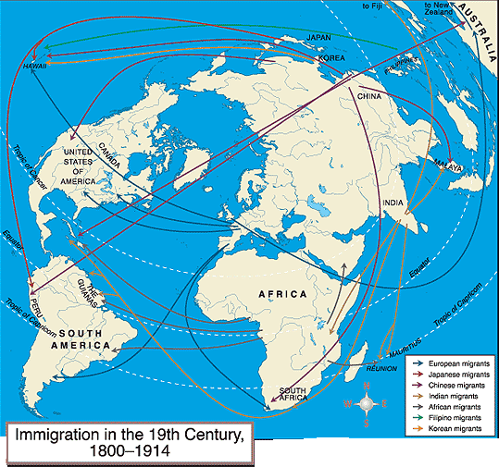
Explain the extent that interregional migration affected society from 1800 to 1910.

Document 1
Excerpts from the Port of Spain Gazette, Trinidad 1851
A letter from a resident of Trinidad:
The universal characteristics of the Hindoos (Indians) are habitual disregard of truth, pride, tyranny, theft, falsehood, deceit, conjugal infidelity, filial disobedience, ingratitude (the Hindoos have no word expressive of thanks), a litigious spirit, perjury, treachery, covetousness, gaming, servility, hatred, revenge, cruelty, private murder, the destruction of illegitimate children..
Editorial:
[Africans and other laborers are] "no longer to be found in the cane fields because the local government has driven them from the fields by introducing the East Indians who will work for twenty cents per day or less, because they are half naked, deeply degraded, and herb-eating."

Document 2

Congress of the United States, Chinese Exclusion Act, 1882

Whereas in the opinion of the Government of the United States the coming of Chinese laborers to this country endangers the good order of certain localities within the territory thereof: Therefore,
Be it enacted by the Senate and House of Representatives of the United States of America in Congress assembled, That from and after the expiration of ninety days next after the passage of this act, and until the expiration of ten years next after the passage of this act, the coming of Chinese laborers to the United States be, and the same is hereby, suspended; and during such suspension it shall not be lawful for any Chinese laborer to come, or having so come after the expiration of said ninety days to remain within the United States.

Document 3
Phillip May, Australian cartoonist, “The Mongolian Octopus – His Grip on Australia”, published in The Sydney Bulletin, 21 August 1886.
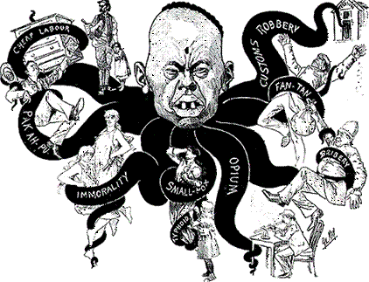

Document 4
Dr. Robert G. Eccles, American scientist and sociologist, essay from a chapter entitled “The Immigration Problem”, from Man and the state; studies in applied sociology, 1892
The danger from foreigners comes when they form a nest, 'as it were – when the Chinese cluster together as they do in San Francisco and defy our Government and civilization, and send out thence a poisonous influence, just like the bacteria in our bodies. Such performances as those of the Clan-na-Gael (Irish republican organization) in Chicago, and of the Irish in New York on St. Patrick’s Day, are examples. We should not allow foreigners to foster foreign ideas in this country. As long as they do it we are in danger from such organizations as the Mafia in New Orleans. The concentration of foreign elements from one nation in one place and the development there of their national characteristics is dangerous. Our safety lies in letting the evil tendencies of different nations check each other. Let one evil kill another. Let the mean, selfish characteristics of the Irish clash with and kill the mean, selfish characteristics of the Germans, and so forth.

Document 5
An editorial from the Indian Opinion, South Africa 4 June 1904.

The demand for Indian labour seems to be increasing at an alarming rate. There were, at the end of the year, 15,033 applications undealt with. The Agent in India is utterly unable to cope with this extraordinary demand. It shows that the Colony simply cannot do without indentured Indian labour, and yet we hear men crying out against it, and arguing that the Colony has been ruined by indentured Indian labour.
We have received from the Protector of Indian Immigrants a copy of his annual report for the year ended 31st December 1903. The indentured Indian population of the Colony, including the descendants of such Indians, at the end of the year, was 81,390 as against 31,712 in the year 1896… Plague claimed 52 victims during the year under review; pneumonia and other lung complaints 328 and tuberculosis 262. These figures are rather disquieting and require careful investigation. As has been remarked in the report, in the coalmines the death rate among the Indians has been rather high. Of 40 deaths occurring among the small number of Indians within the mining circle.

