AP World History DBQ 2020

Reading and writing time: 45 minutes
It is suggested that you spend 10 minutes reading the documents and 35 minutes writing your response.

Directions: The Document-Based Question is based on the accompanying documents. The documents have been edited for the purpose of this exercise

In your response you should do the following.
- Respond to the prompt with a historically defensible thesis or claim that establishes a line of reasoning
- Describe a broader historical context relevant to the prompt.
- Support an argument in response to the prompt using at least four documents.
- Use one or two additional pieces of specific evidence (beyond that found in the documents) relevant to an argument about the prompt.
- For two documents, explain how or why the document’s point of view, purpose, historical situation, and\or audience is relevant to an argument.
- Use evidence to corroborate, qualify, or modify an argument that addresses the prompt.

Prompt: Evaluate the extent that Enlightenment ideas affected gender roles between 1750 and 1900.

Document 1
Olympe de Gouges, French revolutionary, from Declaration of the Rights of Women, published 1791

Oh, women, women! When will you cease to be blind? What advantage have you received from the Revolution? A more pronounced scorn, a more marked disdain. In the centuries of corruption, you ruled only over the weakness of men. The reclamation of your patrimony, based on the wise decrees of nature-what have you to dread from such a fine undertaking?... Do you fear that our French legislators, correctors of that morality, long ensnared by political practices now out of date, will only say again to you: women, what is there in common between you and us? Everything, you will have to answer…. unite yourselves beneath the standards of philosophy; deploy all the energy of your character, and you will soon see these haughty men, not groveling at your feet as servile adorers, but proud to share with you the treasures of the Supreme Being. Regardless of what barriers confront you, it is in your power to free yourselves; you have only to want to….

Document 2
Mary Wollstonecraft, English writer and reformer, from A Vindication of the Rights of Woman, 1792

I would not lead my readers to suppose that I mean violently to agitate the contested question respecting the equality or inferiority of the sex; but . . . I shall stop a moment to deliver, in a few words, my opinion. In the government of the physical world it is observable that the female in point of strength is, in general, inferior to the male. This is the law of nature; and it does not appear to be suspended or abrogated [abolished] in favor of woman. A degree of physical superiority cannot, therefore, be denied— and it is a noble prerogative [right]! But not content with this natural preeminence, men endeavor to sink us still lower, merely to render us alluring objects for a moment…

Document 3
Article from The New York Herald, 1848

This is the age of revolutions. The principal agent, however, that has hitherto taken part in these movements has been the rougher sex. It was by man the flame of liberty, now burning with such fury on the continent of Europe, was first kindled; and though it is asserted that considerable assistance was contributed by the gentler sex in the late bloody carnage at Paris, we are disposed to believe that such a revolting claim proceeds from base calumniators, and is s libel upon women…
The flag of independence has been hoisted for the second time on this side of the Atlantic; and a solemn league and covenant has just been entered into by a convention of women at Seneca Falls, to “throw off the despotism under which they are groaning, and provide new guards for their future security”…
After a discussion of two days… a declaration was adopted and signed. The most amusing part is the preamble, where they assert their equality, and that they have certain inalienable rights… and that after the long train of abuses, it is their duty to throw off [their] government.

Document 4
Cartoon from the British magazine Fun, 12 June 1875

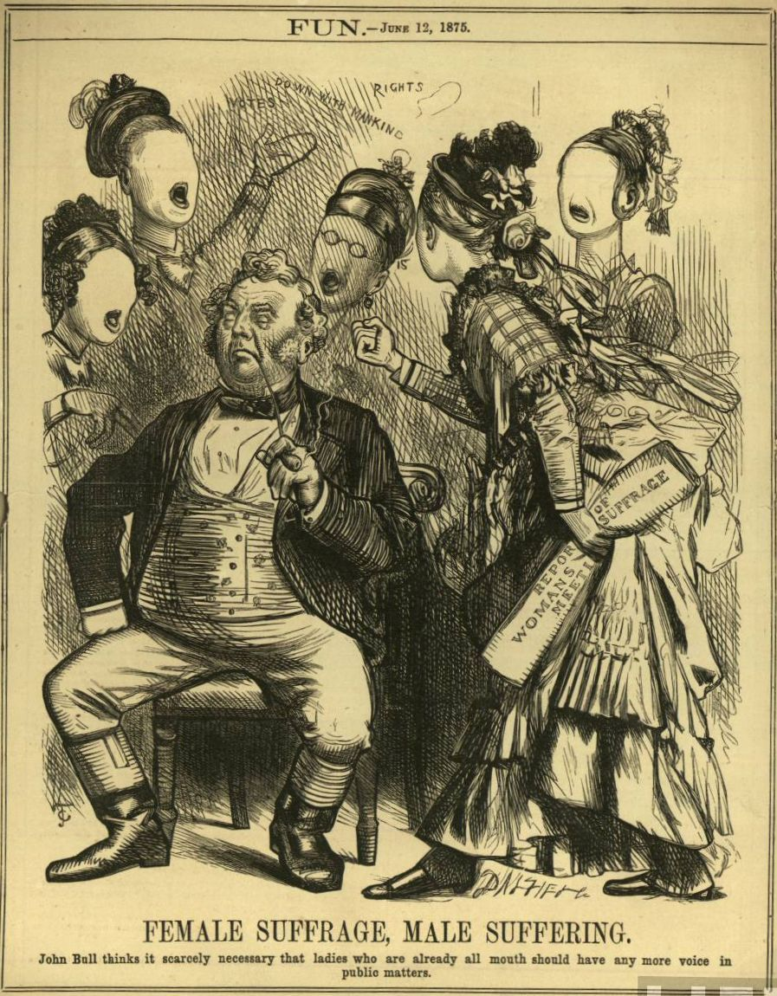

Document 5
Part of the Electoral Act, New Zealand, 1893

QUALIFICATION OF ELECTORS.

Qualifications Male or Female:

The members of the House of Representatives shall be chosen in every electoral district appointed for that purpose by the votes of the inhabitants of New Zealand who shall possess within the district the qualifications defined by this Act, that is to say,
- Every person of the age of twenty-one years or upwards having, of his own right, and not as a trustee, a freehold estate in possession situated within any electoral district of the value of twenty-five pounds…

