TWTW: Hitler and Stalin: Roots of Evil (Learn 360)
- Watch Hitler and Stalin: Roots of Evil: introduction
Discuss
- Watch Segment 6: Military Service and Rise to Power (04:11)
What role did military service play in Hitler and Stalin’s rise to power?
___________________________________________________________________________________
- Watch Segment 9: Brutal Dictatorships (03:28)
How did Hitler maintain power?
__________________________________________________________________________________
What did Stalin do to his rival, Kirov?
__________________________________________________________________________________

How many Soviet citizens did Stalin eliminate? ____________________________________________

- Watch Segment 10: Stalin Revises History (02:43)
How did Stalin eliminate the memory of his enemies?
__________________________________________________________________________________

- Watch Segment 11: Hitler Revises History (02:56)
What did Hitler do to eradicate his “dark secret”?

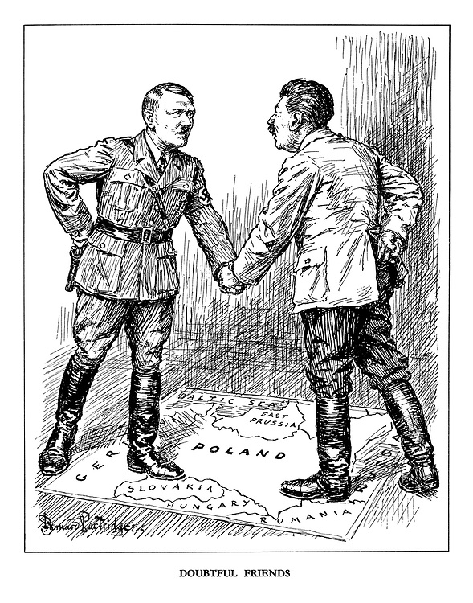
- Analyze the cartoon (explain the historical situation and the artist’s purpose.)

Bernard Partridge, British cartoonist, from Punch, 1939

- Evaluate the extent that methods used to maintain order by absolutist systems of the 17th and 18th centuries are similar to those used by totalitarian systems of the 20th century. (ONE paragraph concerning similarities with evidence and analysis, ONE for differences.)
__________________________________________________________________________________________________________________________________________________________________________________________________________________________________________________________________________________________________________________________________________________________________________________________________________________________________________________________________________________________________________________________________________________________________________________________________________________________________________________________________________________________________________________________________________________________________________________________________________________________________________________________________________________________________________________________________________________________________________________________________________________________________________________________________________________________________________________________________________________________________________________________________________________________________________________________________________________________________________________________________________________________________________________________________________________________________________________________________________________________________________________________________________________________________________________________________________________________________________________________________________________________________________________________________________________________________________________________________________________________________________________________________________________________________________________________________________________________________________________________________________________________________________________________________________________________________________________________________

