Nuremberg Laws Analysis Questions: Name: ______________________________________________ Period: ________

Law 1: German Citizenship Law

1. What is a German citizen?

2. What does a German citizen have to prove?

3. What rights does a German citizen have?

Law 2: Law for the Protection of German Blood and German Honor

4. What is the “most important condition for the continued existence of the German people”?

5. What besides marriage was forbidden between Germans and Jews?

6. In your opinion, why were Jews forbidden to hire German women younger than 45 years?

7. In your opinion, why were Jews forbidden from displaying the German flag?

8. In your opinion, why were Jews allowed to display the Jewish flag?

9. What are some of the punishments for disobeying the Nuremberg Laws?

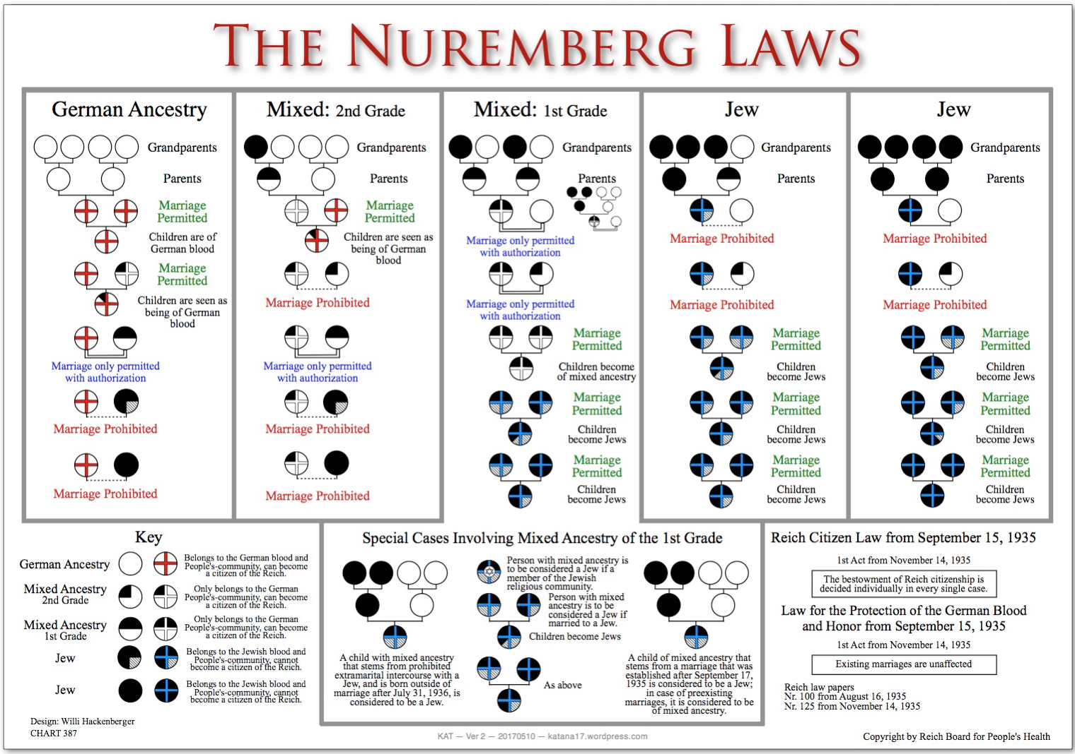
Nuremberg Laws Race Chart

Use the Nuremberg Laws Race Chart to answer the following questions.

10. If a person has 4 German grandparents, what are they?

11. If a person has 1 Jewish grandparent, what are they?

12. If a person has 2 Jewish grandparents, what are they?

13. If a person has 3 or 4 Jewish grandparents, what are they?

14. How can a person with 2 Jewish grandparents marry a person of German ancestry?

15. Can a person with 3 Jewish grandparents marry a person of German ancestry?

16. What about marriages before the Nuremberg Laws took effect?

17. What are your thoughts on the Nuremberg Laws? Do people have a right to make laws like this? Write 3-5 sentences.

_________________________________________________________________________________________________________________________

_________________________________________________________________________________________________________________________

_________________________________________________________________________________________________________________________

_________________________________________________________________________________________________________________________

_________________________________________________________________________________________________________________________

_________________________________________________________________________________________________________________________

