Persia Rome Name: ____________________

S S

P
P

E

E
C
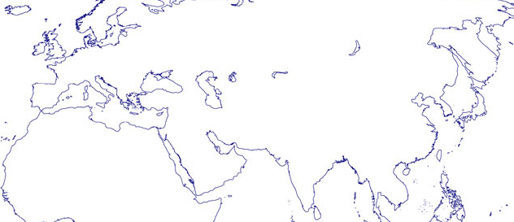
Classical Empires Snapshot

C

India (Mauryan\Gupta) Han China

S S

P
P

E E

C C

1. List at least 4 common characteristics of empire building. COMMON MEANS THEY ALL HAVE IT!

2. List the most important leader of each empire and explain why they are important

Persian Achaemenid Empire

Roman Empire

Mauraya/Gupta Empire

Han Empire

