Unit 2 Summary and Sourcing

For each document, write a short (one or two sentences) summary and then explain the source. (This is done by describing how or why the document’s purpose, historical situation, the author’s point of view, and /or the audience is relevant to the argument.)

Make notes below each document, then type your work and send as a double-spaced Word attachment to your teacher’s email before midnight April 19.

Prompt: Evaluate the extent that the expansion of empires influenced trade and communication between 1200 and 1450.
Document 1
Inscribed metal paizi or passport used as a symbol for Mongol administration, inscribed with the words: “By the strength of Eternal Heaven, an edict of the Emperor [Khan].He who has no respect shall be guilty.’ c. 1300
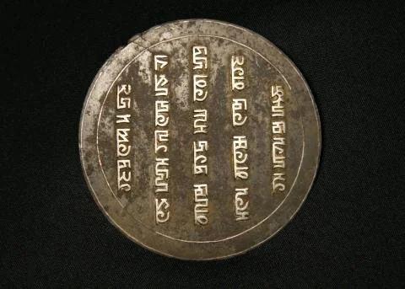

__________________________________________________________________________________________________________________________________________________________________________________________________________________________________________________________________________________________________________________________________________________________________________________________________________________________________________________________________________________________________________________________________________________________________
Document 2
Unknown Chinese writer, excerpt from The Attractions of the Capital (Hangzhou), 1325
During the morning hours, markets extend from Tranquility Gate of the palace all the way out to the north and south sides of the New Boulevard .Here we find pearl, jade, talismans, exotic plants and fruits, seasonal catches from the sea, wild game—all the rarities of the world seem to be gathered here. Commercial Establishments Various businesses are designated by the word “company,” which is a taxation category imposed by the government and used for all businesses dealing in commodities, regardless of their size. Even physicians and fortunetellers are included.… In general, the capital attracts the greatest variety of goods and has the best craftsmen.
__________________________________________________________________________________________________________________________________________________________________________________________________________________________________________________________________________________________________________________________________________________________________________________________________________________________________________________________________________________________________________________________________________________________________

Document 3
Francesco Pegolotti, a Florentine merchant, excerpt from his Merchant Handbook, c. 1350
The road you travel from Tana [at the mouth of the Don River] to Cathay [China] is perfectly safe, whether by day or by night, according to what the merchants say who have used it…
You may calculate that a merchant with a dragoman, and with two men servants, and with goods to the value of twenty-five thousand golden florins, should spend on his way to Cathay from sixty to eighty sommi of silver…
Whatever silver the merchants may carry with them as far as Cathay the lord of Cathay will take from them and put into his treasury. And to merchants who thus bring silver they give that paper money of theirs in exchange. This is of yellow paper, stamped with the seal of the lord aforesaid. And this money is called balishi; and with this money you can readily buy silk and all other merchandise that you have a desire to buy. And all the people of the country are bound to receive it. And yet you shall not pay a higher price for your goods because your money is of paper…
__________________________________________________________________________________________________________________________________________________________________________________________________________________________________________________________________________________________________________________________________________________________________________________________________________________________________________________________________________________________________________________________________________________________________

Document 4
Ibn Battuta, Muslim Traveler from Morocco, from Travels in Asia and Africa, c. 1340
On leaving Zayla we sailed for fifteen days and came to Mogadishu [on the Swahili Coast], which is an enormous town. Its inhabitants are merchants and have many camels, of which they slaughter hundreds every day [for food]. When a vessel reaches the port, it is met by sumbuqs, which are small boats, in each of which are a number of young men, each carrying a covered dish containing food. He presents this to one of the merchants on the ship saying, "This is my guest," and all the others do the same. Each merchant on disembarking goes only to the house of the young man who is his host, except those who have made frequent journeys to the town and know its people well; these live where they please. The host then sells his goods for him and buys for him, and if anyone buys anything from him at too low a price or sells to him in the absence of his host, the sale is regarded by them as invalid. This practice is of great advantage to them.
__________________________________________________________________________________________________________________________________________________________________________________________________________________________________________________________________________________________________________________________________________________________________________________________________________________________________________________________________________________________________________________________________________________________________

