Thesis Statement: Unit 4 Transoceanic Connections, 1450 - 1750
Study the documents, and then make a plan.
Argument Categories | Document #s | Document Sourcing (POV)
Create a thesis statement that responds to the prompt. You will need to create a thesis paragraph which will show your thesis statement followed by your historically defensible arguments (argument 1, 2, possibly 3) (Cothran refers to this as groupings). You will need at least 3 sentences total!
Send the thesis as a double-spaced Word attachment to your teacher before midnight April 26.

Prompt: Evaluate the extent that technological developments affected interregional connections between 1400 and 1750.

Document 1
Zheng He, admiral of Ming China, c. 1405.

Under order of the Yongle Emperor I am to set out on a voyage of trade and exploration as the admiral of several fleets. I have spent the past few years building a massive fleet of 317 ships and 28,000-armed crew. We travel to the Indian Ocean and Southeast Asia in order to spread the influence of the Yongle Emperor and establish control over these maritime trade routes.

- I have admired the great Nine-masted travel ships which I will both travel with and command on our journeys into the unknown. Each one neigh able to hold a quarter of a thousand men. Each crew shall hold more than just merchants and arms-men, but doctors, missionaries, astrologers, cooks, and translators. This fleet of swimming dragons may lead China to great success.

Document 2
Raimondo di Soncino, ambassador of the Duke of Milan in London, from his message to the Duke of Milan, 1497.
My most illustrious and most excellent Lord,
Perhaps amidst so many occupations of your Excellency it will not be unwelcome to learn how the king of England has acquired a part of Asia without drawing his sword. In this kingdom there is a certain Venetian named Zoanne Caboto, of gentle disposition, very expert in navigation, who, seeing that the most serene Kings of Portugal and Spain had occupied unknown islands, meditated the achievement of a similar acquisition for the said Majesty. Having obtained royal privileges … he entrusted his fortune to a small vessel with a crew of 18 persons, and set out from Bristol, a port in the western part of this kingdom. Having passed Ibernia, which is still further to the west, and then shaped a northerly course, he began to navigate to the eastern part, leaving (during several days) the North Star on the right hand; and having wandered thus for a long time, at length he hit upon land, where he hoisted the royal standard, and took possession for his Highness, and, having obtained various proofs of his discovery, he returned. … This Messer Zoanne has the description of the world on a chart, and also on a solid sphere which he has constructed, and on which he shows where he has been…[and] they took so many fish that this kingdom will no longer have need of Iceland, from which country there is an immense trade in the fish they call stock-fish.

Document 3
Girolamo Priuli, a noble of Venice, from his diary, 1501.

This news, as has been said above, was considered very bad news for the city of Venice... Whence it is that the King of Portugal has found this new voyage, and that the spices which were expected which should come from Calicut [Calcutta], Cochin, and other places in India, to Alexandria or Beirut, and later come to Venice, and in this place become monopolized, whence all the world comes to buy such spicery and carry gold, silver, and every other merchandise, with which money the war is sustained; today, with this new voyage by the King of Portugal, all the spices which came by way of Cairo will be controlled in Portugal, because of the caravels which will go to India, to Calicut, and other places to take them. And in this way the Venetians will not be able to take spices either in Alexandria or Beirut.

Document 4
Martin Waldseemüller, a German cartographer, Tabula Terre Nove (Map of the New Lands), the first map of the Americas published in an atlas, 1513

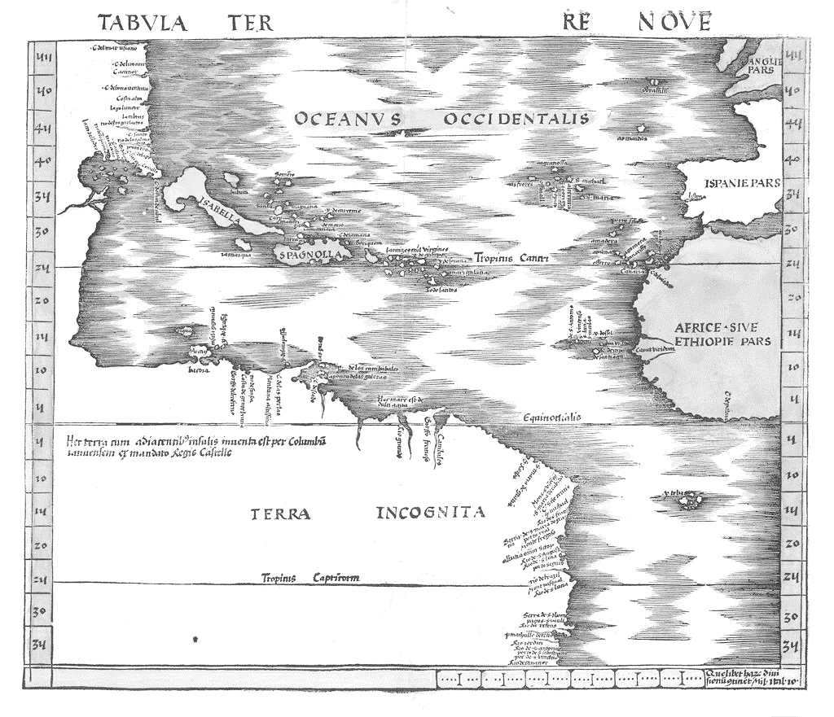

Document 5
Marquis Carlos Francisco de Croix, a Spanish general and viceroy of New Spain, from a letter to the Marquis de Henchin, 1769.

"The greater part of the people who each year go from New Spain to the Philippines do not remain there, but return presently, after employing the money which they have.
The failure of the Manila Galleon to arrive causes a scarcity of many things in this country…[the shipment] promises a more brilliant fair at Jalapa, (the town in the tierra templada above Vera Cruz). All classes, from the Indians of the torrid lowlands to the Creoles of the capital are dressed in the fabrics of the Far East — the cottons of Luzon or India, or the silks of China.

The Chinese goods form the ordinary dress of the natives of New Spain. The Philippine commerce is acclaimed in this kingdom, because its merchandise supplies the poor folk of the country."

