Contextualization: Unit 3 Land-Based Empires

Study the documents, make a plan.

Argument Categories | Document #s | Document Sourcing (POV)
Contextualization

Create a contextualization that responds to the prompt.
Send the contextualization as a double-spaced Word attachment before midnight Thursday the 23rd.

Prompt: Evaluate the extent to which strategies used by the rulers of the Ottoman and Russian empires to legitimize and consolidate their power between 1500 and 1800 were similar.

Document 1
Ottoman Sultan Suleiman the Magnificent, the introduction to a letter sent to King Francis I of France, 1526.

I, who am the sultan of sultans, the sovereign of sovereigns, the dispenser of crowns to the monarchs on the face of the earth, shadow of god on earth, the sultan and sovereign lord of the Mediterranean and the Black Sea, of Rumelia and Anatolia, of Karamania and the land of Rum, of Zulkadria, Diyarbakir, of Kurdistan, of Azerbaijan, Persia, Damascus, Cairo, Aleppo, of the Mecca and Medina, of Jerusalem, of all Arabia, of the Yemen and many other lands, which my noble forefathers and my glorious ancestors - may God light up their tombs - conquered by the force of their arms and which my august majesty has made subject to my flaming sword and victorious blade, I, Sultan Süleyman Han, to thee, who art Francis, king of the land of France.

Document 2
Ogier Ghiselin de Busbecq, a Flemish nobleman who was sent as a diplomat to the Ottoman Empire by the Austrian Empire, c. 1560.
The Sultan’s hall was crowded with people, among whom were several officers of high rank. Besides these there were all the troopers of the Imperial guard and a large force of Janissaries; but there was not in all that great assembly a single man who owed his position to aught save his valor and his merit. No distinction is attached to birth among the Turks…
Among the Turks, therefore, honors, high posts, and judgeships are the rewards of great ability and good service. If a man be dishonest, or lazy, or careless, he remains at the bottom of the ladder, an object of contempt; for such qualities there are no honors in Turkey! This is the reason that they are successful in their undertakings, that they lord it over others, and are daily extending the bounds of their empire.

Document 3
Russia czar, Peter the Great, Decree on Foreigners, 1701.
Since our accession to the throne all our efforts and intentions have tended to govern this realm in such a way that all of our subjects should, through our care for the general good, become more and more prosperous. For this end we have always tried to maintain internal order, to defend the state against invasion, and in every possible way to improve and to extend trade. With this purpose we have been compelled to make some necessary and salutary changes in the administration, in order that our subjects might more easily gain a knowledge of matters of which they were before ignorant, and become more skillful in their community relations. We have therefore given orders, made dispositions, and founded institutions indispensable for increasing our trade with foreigners, and shall do the same in the future…. To attain these worthy aims, we have endeavored to improve our military forces, which are the protection of our State, so that our troops may consist of well-drilled men, maintained in perfect order and discipline. In order to obtain greater improvement in this respect, and to encourage foreigners, who are able to assist us in this way, as well as artisans profitable to the State, to come in numbers to our country, we have issued this manifesto.

Document 4
Russian czar, Peter the Great, Decree on Promotion to Officer’s Rank, 1714.
“Since there are many who promote to officer rank their relatives and friends – young men who do not know the fundamentals of soldiering, not having served in the lower ranks – and since even those who serve [in the ranks] do so for a few weeks or months only, as a formality; therefore…let a decree be promulgated that henceforth there shall be no promotion [to officer rank] of men of noble extraction or of any others who have not first served as privates in the Guards. This decree does not apply to soldiers of lowly origin who, after long service in the ranks, have received their commissions through honest service or to those who are promoted on the basis of merit, now or in the future….”

Document 5
Louis Caravaque, French painter living in Russia during the reign of Peter the Great

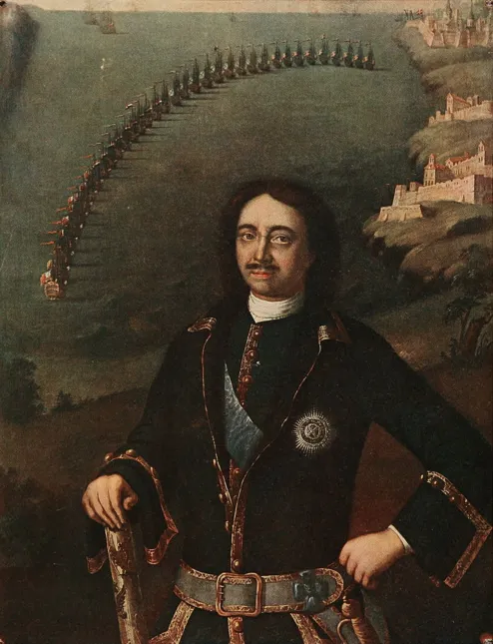

Peter the Great with Russian Navy, 1716

