Unit 3: Land Based Empires Summary and Sourcing

For each document, write a short (one or two sentences) summary and then explain the source. (This is done by describing how or why the document’s purpose, historical situation, the author’s point of view, and /or the audience is relevant to the argument.)

Type your work and send as a double-spaced Word attachment to your teachers email before midnight April 19.

Prompt: Evaluate the extent toleration enabled the Ottoman Empire to consolidate power between 1450 and 1750.

Document1
George Sphrantzes, Byzantine Greek historian and Imperial courtier. who witnessed the fall of Constantinople, later recalled in his Χρονικόν (Chronicle), c. 1476

“…the sultan celebrated his victory with a great, joyful triumph. He issued a Proclamation: the citizens of all ages who had managed to escape detection were to leave their hiding places throughout the city and come out into the open, as they were remain free and no question would be asked. He further declared the restoration of houses and property to those who had abandoned our city before the siege, if they returned home, they would be treated according to their rank and religion, as if nothing had changed”

Document 2
Ogier Ghiselin de Busbecq, the Imperial Ambassador from the court of Holy Roman Emperor Ferdinand-I during the time of Süleyman the Magnificent, in a letter to his friend and fellow diplomat, Nicholas Michault, c. 1560

“A man cannot rise to high rank just because he comes of a great family…. When Sultan appointed a man to any post, he neither attached any importance to his wealth, nor listened to any empty entreaties. He looked only for capability, character, innate ability and talent; in this way everyone is rewarded according to his own capability and talent. In every post there is a man who can do his work thoroughly. In Turkey everyone is the creator and patron of his position and his reward… The Turks do not believe that talent and capability can be inherited in any way…Dishonest; lazy and inactive men can never rise to high rank, but always remain in an insignificant, low position. The secret of why the Turks have succeeded in every attempt they have made and have become a ruling race that increases their boundaries every day is simply this”

Document 3
Salomon Schweigger, German Lutheran minister who travelled in the Ottoman Empire in 1578, engraving “Ottomans with Christian slaves”, 1608
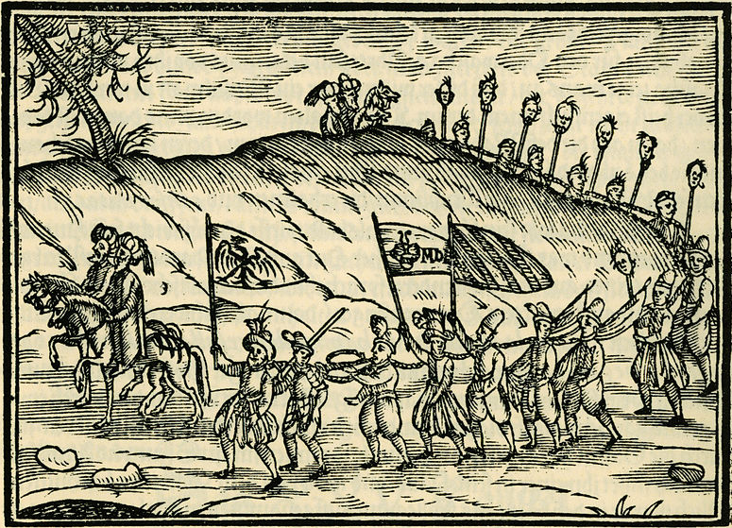

Document 4
Sir James Porter, British diplomat and ambassador to the Ottoman Empire, from a memoir, 1768

“In every empire which has extended wide, and it is certain that, whatever defects may be in the political system of the Turks, their Empire is so solidly founded on the basis of religion, combined with law, and so firmly cemented by general enthusiasm, and the interest, as well as vanity, of the Turkish individual, that it has lasted ages, and bids fair for stability and permanence”

