Unit 6: Evidence beyond the documents
Your task: Write a body paragraph that ties back to one of the categories of your plan. Make sure there is a clear topic sentence that uses key terms from the prompt. Your paragraph must incorporate at least one of the documents.
Make sure to include a piece of evidence beyond the documents that is relevant to your argument. You must explain why it is relevant and not just drop it in! Place an * by the sentences you would like to be considered for outside evidence (evidence beyond the documents).

Historical Background: The maps below show European expansion in Africa from 1878 to 1914.
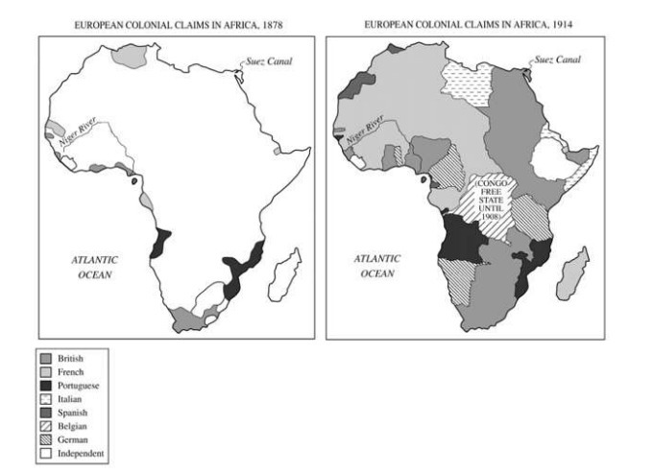

Prompt: Evaluate the motivations behind the European acquisition of African colonies in the period 1850 to 1914.
Argument Categories | Document #s | Document Sourcing (POV) + evidence beyond

Document 1
Source: Prince Leopold, heir to the throne of Belgium and future king, conversation, 1861

Surrounded by the sea, Holland, Prussia and France, our frontiers can never be extended in Europe. . . . [But] the universe lies in front of us; steam and electricity have made distances disappear, all the unappropriated lands on the surface of the globe may become the field of our operations and of our resources. . . . Since history teaches that colonies are useful, that they play a great part in that which makes up the power and prosperity of states, let us strive to get one in our turn . . . let us see where there are unoccupied lands . . . where are to be found peoples to civilize, to lead to progress in every sense, meanwhile assuring ourselves . . . the opportunity to prove to the world that Belgians also are an imperial people capable of dominating and enlightening others.

Document 2
Source: Cartoon titled ‘Wooing the African Venus’, from the British periodical, Punch 1888

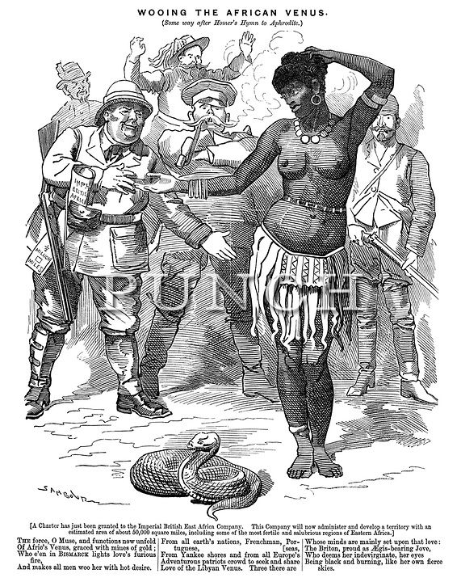

Document 3
Source: George Washington Williams, American Baptist minister, lawyer, historian, and legislator, “An Open Letter to His Serene Majesty, Leopold II, King of the Belgians and Sovereign of the Independent State of Congo,” Stanley Falls, Congo Free State, 1890

Great and Good Friend,
I have the honor to submit for Your Majesty’s considerations some reflections respecting the Independent State of Congo. There were instances in which Mr. Henry M. Stanley* sent one white man, with four or five Zanzibar soldiers, to make treaties with the native chiefs. All the sleight of hand tricks had been carefully rehearsed and he was now ready for his work. A number of electric batteries had been purchased in London and when attached to an arm under the coat, communicated with a band of ribbon which passed over the palm of the white brother’s hand, and when he gave the black brother a cordial grasp of the hand, the black brother was surprised to find his white brother so strong that he nearly knocked him off his feet. By such means as these, and a few boxes of gin, whole villages have been signed away to Your Majesty.
*British-American journalist and explorer sent to Congo by King Leopold of Belgium.

Document 4
Source: Archibald Philip Primrose, Lord Rosebery, British politician and foreign secretary, letter to the London Times, 1900

An Empire such as ours requires as its first condition an imperial race—a race vigorous and industrious and intrepid. Health of mind and body exalt a nation in the competition of the universe. The survival of the fittest is an absolute truth in the conditions of the modern world.

Document 5
Source: Martial Henri Merlin, governor general of French Equatorial Africa, speech to the Chamber of Deputies, 1910

We went to new territories. We went there by virtue of the right of a civilized, fully developed race to occupy territories which have been left fallow by backward peoples who are plunged into barbarism and unable to develop the wealth of their land. What we exercised is a right, and if anyone denies this, you should firmly maintain that it is a right. We are entitled to go out to these peoples and occupy their territories; but, when we exercise this right, we, at the same moment are charged with a duty towards these peoples, and this duty we must never for one instant forget.

