World War I: War Guilt Document Study
- Read and discuss speech and cartoon: (large group)
Sisley Huddleston, British journalist, account of the Opening of the Paris Peace Conference, 18 January 1919
The Peace Conference formally opened on Saturday, January 18th, in the Salle de l'Horloge at the French Foreign Ministry. But for some weeks before there had been a mustering of statesmen from the four corners of the world in Paris, and the French capital, which with its comings and goings of statesmen and generals had for so long been the Capital of the War, was prepared to become the Peace Headquarters.
I think that the strongest criticism that can be made of the Allies is that they permitted two months to slip away before they even proceeded to consider the peace which the armistice promised….
The fate of mankind was poised by a thread. When you came into the sphere of these proceedings you could not avoid a feeling of awe at the terrible responsibilities shouldered by the statesmen, as they were yesterday shouldered by the captains of the Allies and of their associates….
The opening day recalled an event which coloured the subsequent history of Europe. It was the anniversary of that day in 1871 when the German Empire was proclaimed by an army of invasion in the Chateau at Versailles. It was consecrated by the theft of two French provinces, and, as M. Poincare said, was thus vitiated from its origin by the fault of its founders….

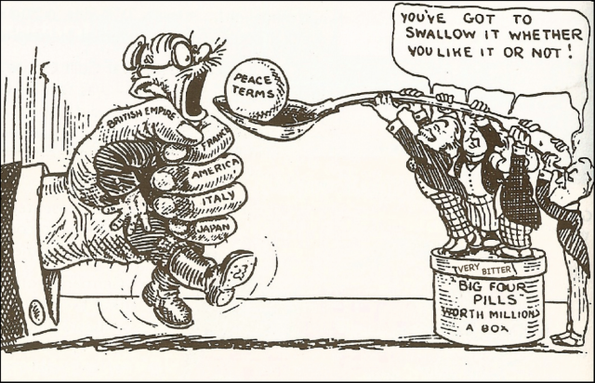
Cartoon depicting Germany being spoon-fed peace-terms (Treaty of Versailles) by the Council of Four, 1919.

2. Study documents and answer questions that follow: (small group)
German Delegates' Protest Against Proposed Peace Terms at the Paris Peace Conference, May 1919
We came to Versailles in the expectation of receiving a peace proposal based on the agreed principles. We were firmly resolved to do everything in our power with a view of fulfilling the grave obligations which we had undertaken. We hoped for the peace of justice which had been promised to us.
We were aghast when we read in documents the demands made upon us, the victorious violence of our enemies. The more deeply we penetrate into the spirit of this treaty, the more convinced we become of the impossibility of carrying it out. The exactions of this treaty are more than the German people can bear….
With a view to the re-establishment of the Polish State we are ordered to renounce indisputably German territory - nearly the whole of the Province of West Prussia, which is preponderantly German; of Pomerania; Danzig, which is German to the core; we are told to let the ancient Hanse town be transformed into a free State under Polish suzerainty. We must agree that East Prussia shall be amputated from the body of the State, condemned to a lingering death, and robbed of its northern portion, including Memel, which is purely German. We must renounce Upper Silesia for the benefit of Poland and Czecho-Slovakia, although it has been in close political connection with Germany for more than 750 years, is instinct with German life, and forms the very foundation of industrial life throughout East Germany….
For fifteen years Rhinish territory must be occupied, and after those fifteen years the Allies have power to refuse the restoration of the country; in the interval the Allies can take every measure to sever the economic and moral links with the mother country, and finally to misrepresent the wishes of the indigenous population.
Although the exaction of the cost of the war has been expressly renounced, yet Germany, thus cut in pieces and weakened, must declare herself ready in principle to bear all the war expenses of her enemies, which would exceed many times over the total amount of German State and private assets….

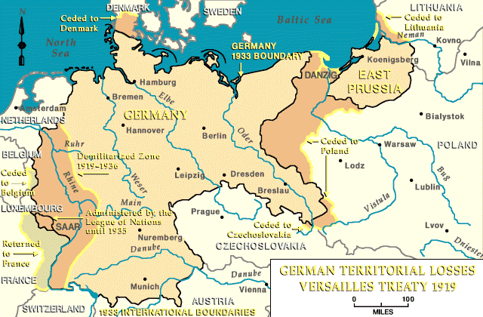

According to the source, what are Germany’s main objections to the terms of the treaty?
______________________________________________________________________________________________________________________________________________________________________________________________________________________________________________________________________________________________________________________________________________________________________________________________________________________________________________________________________________________________________________________________
Georges Clemenceau, French President, Letter of Reply to the Objections of the German Peace Delegation, May 1919
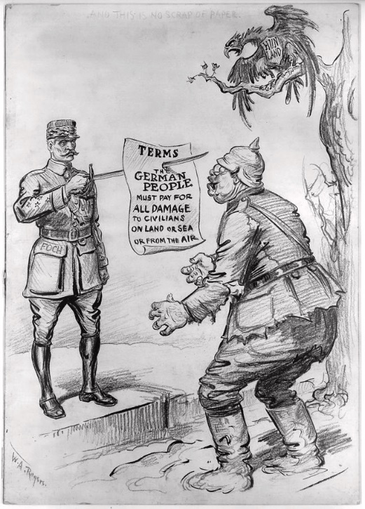
In the view of the Allied and Associated Powers the war which began on August 1, 1914, was the greatest crime against humanity and the freedom of peoples that any nation, calling itself civilized, has ever consciously committed. For many years the rulers of Germany, true to the Prussian tradition, strove for a position of dominance in Europe. They were not satisfied with that growing prosperity and influence to which Germany was entitled, and which all other nations were willing to accord her, in the society of free and equal peoples. They required that they should be able to dictate and tyrannize to a subservient Europe, as they dictated and tyrannized over a subservient Germany.
In order to attain their ends they used every channel in their power through which to educate their own subjects in the doctrine that might was right in international affairs. They never ceased to expand German armaments by land and sea, and to propagate the falsehood that this was necessary because Germany's neighbours were jealous of her prosperity and power.
They sought to sow hostility and suspicion instead of friendship between nations. They developed a system of espionage and intrigue which enabled them to stir up internal rebellion and unrest and even to make secret offensive preparations within the territory of their neighbours whereby they might, when the moment came, strike them down with greater certainty and ease. They kept Europe in a ferment by threats of violence, and when they found that their neighbours were resolved to resist their arrogant will they determined to assist their predominance in Europe by force.
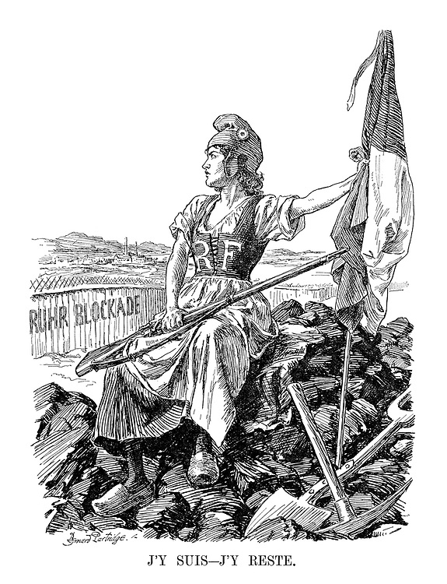
As soon as their preparations were complete, they encouraged a subservient ally to declare war against Serbia at forty-eight hours' notice, knowing full well that a conflict involving the control of the Balkans could not be localized and almost certainly meant a general war. In order to make doubly sure, they refused every attempt at conciliation and conference until it was too late, and the world war was inevitable for which they had plotted, and for which alone among the nations they were fully equipped and prepared.
Germany's responsibility, however, is not confined to having planned and started the war. She is no less responsible for the savage and inhuman manner in which it was conducted.
“Here I am - here I stay
Though Germany was herself a guarantor of Belgium, the ruler of Germany violated, after a solemn promise to respect it, the neutrality of this unoffending people. Not content with this, they deliberately carried out a series of promiscuous shootings and burnings with the sole object of terrifying the inhabitants into submission by the very frightfulness of their action.
They were the first to use poisonous gas, notwithstanding the appalling suffering it entailed. They began the bombing and long-distance shelling of towns for no military object, but solely for the purpose of reducing the morale of their opponents by striking at their women and children. They commenced the submarine campaign with its piratical challenge to international law, and its destruction of great numbers of innocent passengers and sailors, in mid-ocean, far from succor, at the mercy of the winds and the waves, and the yet more ruthless submarine crews.
They drove thousands of men and women and children with brutal savagery into slavery in foreign lands. They allowed barbarities to be practiced against their prisoners of war from which the most uncivilized peoples would have recoiled.
The conduct of Germany is almost unexampled in human history. The terrible responsibility which lies at her doors can be seen in the fact that not less than seven million dead lie buried in Europe, while more than twenty million others carry upon them the evidence of wounds and sufferings, because Germany saw fit to gratify her lust for tyranny by resort to war.

According to the source, what are Clemenceau’s accusations concerning German behavior leading up to World War I?
______________________________________________________________________________________________________________________________________________________________________________________________________________________________________________________________________________________________________________________________________________________________________________________________________________________________________________________________________________________________________________________________
What are Clemenceau’s accusations concerning German behavior during World War I?
______________________________________________________________________________________________________________________________________________________________________________________________________________________________________________________________________________________________________________________________________________________________________________________________________________________________________________________________________________________________________________________________
SAQ Prompt:
- Identify ONE historical development that explains why the World War I peace conference was held at Versailles.
- Identify ONE reason why Germany disputed the terms of the 1919 Treaty of Versailles.
- Explain ONE long-term consequence of the Treaty of Versailles.

Name _________________________

Use a blue or black pen only for the short-answer questions.

__________________________________________________________________________________________________________________________________________________________________________________________________________________________________________________________________________________________________________________________________________________________________________________________________________________________________________________________________________________________________________________________________________________________________________________________________________________________________________________________________________________________________________________________________________________________________________________________________________________________________________________________________________________________________________________________________________________________________________________________________________________________________________________________________________________________________________________________________________________________________________________________________________________________________________________________________________________________

